select P.Name as ProductName,Description,C.Name as CustomerName

from dbo.BuyHistory

left outer join dbo.Clients C on dbo.BuyHistory.ClientID = C.ClientID

left outer join dbo.Products P on dbo.BuyHistory.ProductID = P.ProductID’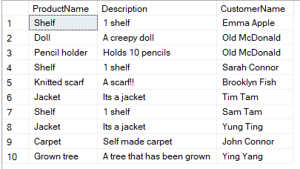

select W.Name as CashierName,C.Name as ClientName,P.Name as ProductName

from dbo.SellHistory

left outer join dbo.Workers W on dbo.SellHistory.WorkerID = W.WorkerID

left outer join dbo.Clients C on dbo.SellHistory.ClientID = C.ClientID

left outer join dbo.Products P on dbo.SellHistory.ProductID = P.ProductID

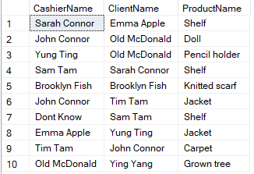

select W.Name as CashierName,ProductID

from dbo.SellHistory

inner join dbo.Workers W on dbo.SellHistory.WorkerID = W.WorkerID

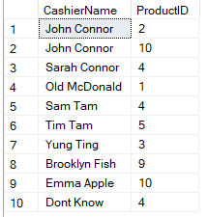

insert into dbo.Workers(WorkerID,Name,Email,Phone,Address)

values

(1,'John Connor','john@connor.com','+111111111','Olive Street 13'),

(2,'Sarah Connor','sarah@connor.com','+21378123','Apple Street 47'),

(3,'Old McDonald','mc@donald.com','+712984','Gun Street 82'),

(4,'Sam Tam','sam@tam.com','+712894','Computer Street 2173'),

(5,'Tim Tam','tim@tam.com','+1768924','Melon Street 23'),

(6,'Yung Ting','yung@ting.com','+172849','Pineapple Street 653'),

(7,'Ying Yang','ying@yang.com','+71284142','Funny Street 125'),

(8,'Brooklyn Fish','brooklyn@fish.com','+7981237981','IdontKnow Street 69'),

(9,'Emma Apple','emma@apple.com','+71824','You Street 137'),

(10,'Dont Know','dont@know.com','+11111141','Car Street 921')

insert into dbo.SellHistory(WorkerID,ClientID,ProductID)

values

(2,1,4),

(1,3,2),

(6,3,3),

(4,2,4),

(8,10,9),

(1,5,10),

(10,6,4),

(9,7,10),

(5,8,5),

(3,9,1)

insert into dbo.BuyHistory(ClientID,ProductID)

values

(1,4),

(3,2),

(3,3),

(2,4),

(10,9),

(5,10),

(6,4),

(7,10),

(8,5),

(9,1)

insert into dbo.Clients(ClientID,Name,Email,Phone)

values

(1,'Emma Apple','emma@apple.com','+71824'),

(2,'Sarah Connor','sarah@connor.com','+21378123'),

(3,'Old McDonald','mc@donald.com','+712984'),

(4,'Dont Know','dont@know.com','+11111141'),

(5,'Tim Tam','tim@tam.com','+1768924'),

(6,'Sam Tam','sam@tam.com','+712894'),

(7,'Yung Ting','yung@ting.com','+172849'),

(8,'John Connor','john@connor.com','+111111111'),

(9,'Ying Yang','ying@yang.com','+71284142'),

(10,'Brooklyn Fish','brooklyn@fish.com','+7981237981')

insert into dbo.Products(ProductID,Name,Description,Price)

values

(1,'Grown tree','A tree that has been grown',5000.99),

(2,'Doll','A creepy doll',1.99),

(3,'Pencil holder','Holds 10 pencils',5.99),

(4,'Shelf','1 shelf',2.00),

(5,'Carpet','Self made carpet',99.99),

(6,'Small toy car','A car',3.99),

(7,'Table','A table from wood',19.38),

(8,'Chair','A chair from wood',15.60),

(9,'Knitted scarf','A scarf!!',6.99),

(10,'Jacket','Its a jacket',3.99)

create proc spGetAllWorkers

as begin

select \* from dbo.Workers

end